**Customer Personality Analysis**

*Wireframe Documentation*

**Analysis:**

1.Age

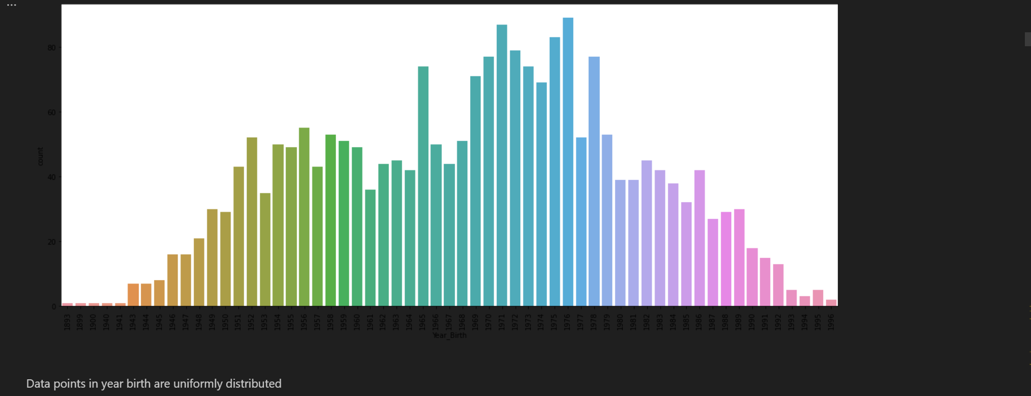

2.Education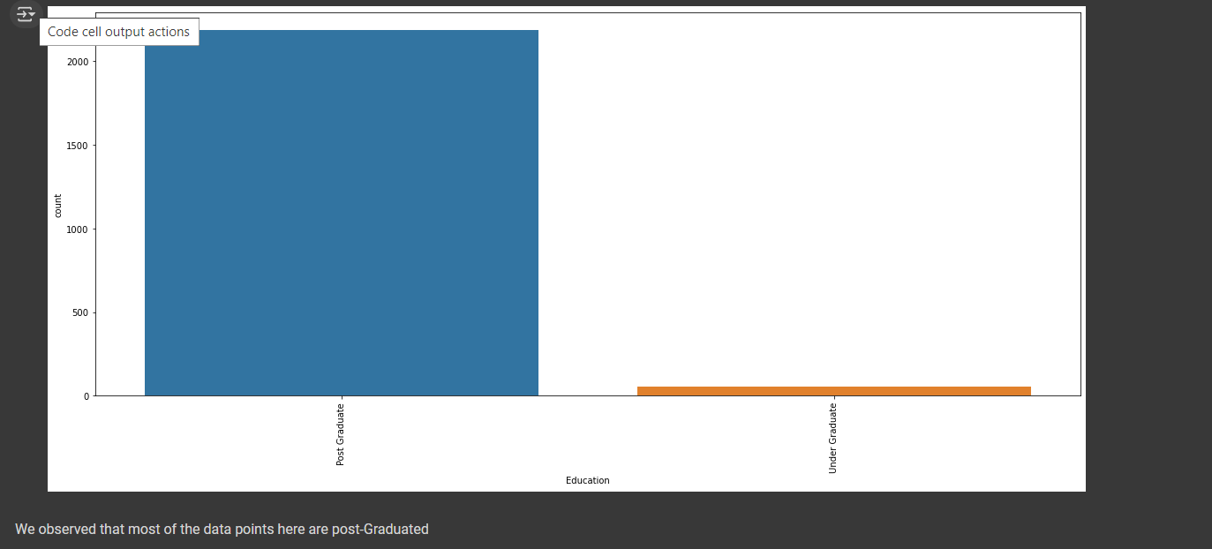

Blue for post graduate and orange for under graduate

3.Marital Status

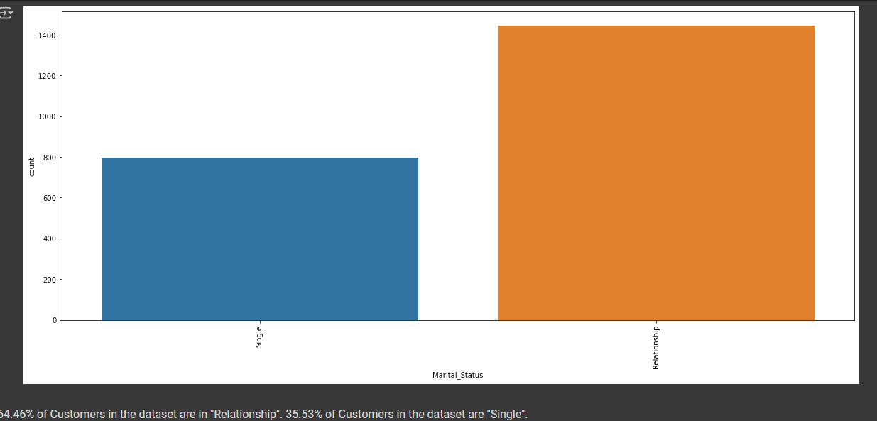

4.Income

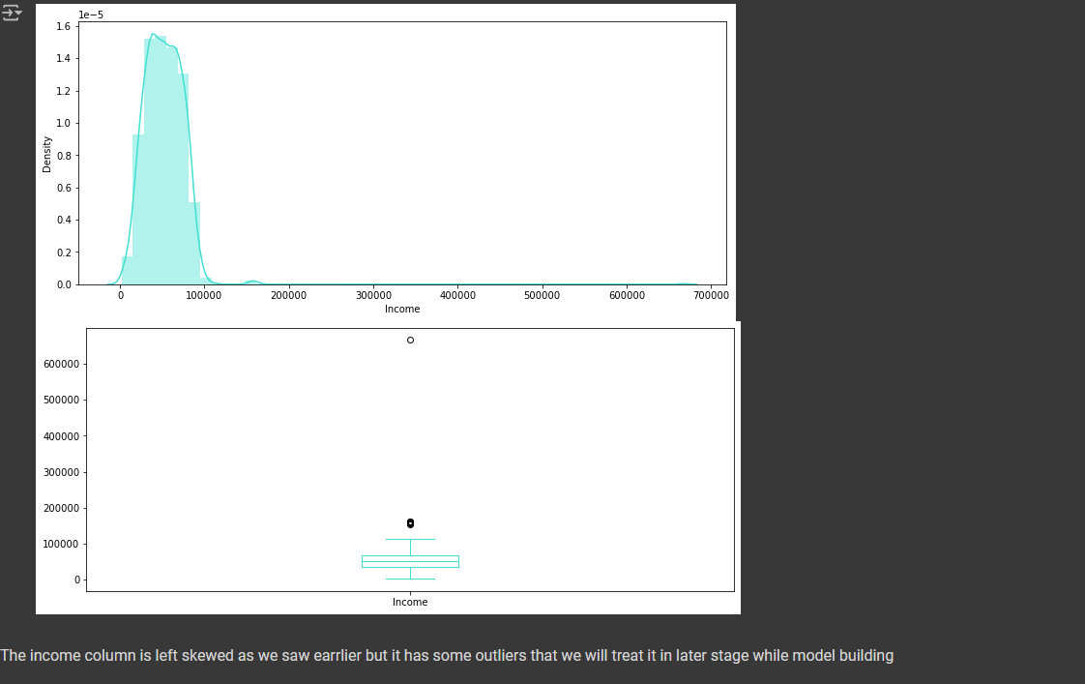

**Impact**

1.How Education impact expenses

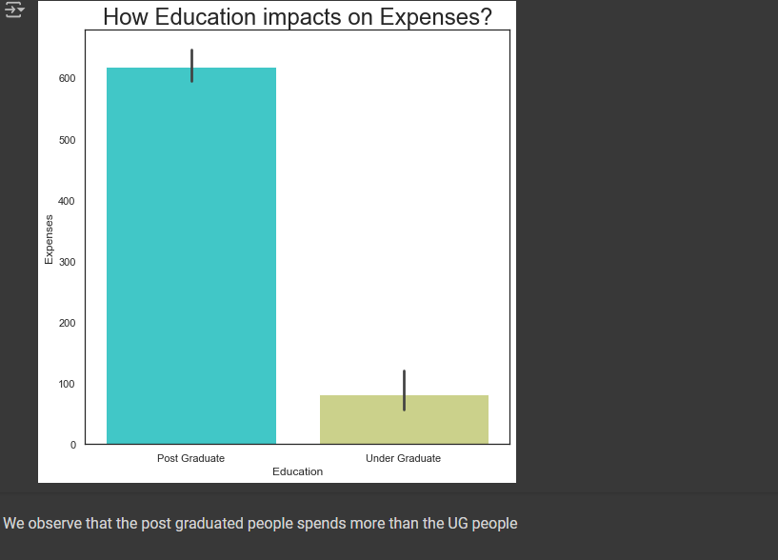

2.How Marital Status impact Expenses

